THE UGANDA INTERGOVRNMENTAL FISCAL TRANSFERS (UGIFT)

REPORT ON THE FINDINGS OF HEALTH CENTERS IN KOBOKO MUNICIPALITY – WESTNILE REGION

Damte: 8th / 09/ 2026

KOBOKO MUNICIPALITY – WESTNILE SUB REGION TC:
- Mr. Patrick Ogweng warmly welcomed the team and introduced us to the , DHO and Accounting office.
- They helped the team to inform the focal person on the facilities.
- The district did not have specific register for the UGIFT asset that were provided to the specific facilities in our Scope.

, NYANGILIA HEALTH CENTER III ,SOUTH DIVISION – KOBOKO MUNICIPALITY
Narratives from the focal person in charge of the facility. To a larger extent the facility has benefited from the UGIFT Programme

FINDINGS
- 1 maternity ward building and general ward
- OPD building
- 1 Toilet and bath room
- 1 Kitchen
- All the required medical assets as listed in the attached facility register below and some of the photos.
- 3 Residential blocks with 6 units for medical staff
- 3 toilets with 2and kitchen with 2 units for medical staff
- Fence for both the staff and the health facility.
- 5 Water tanks for both staff and the health facility.

CHALLENGES
- Few medical personnel
- Few staff quarter
- Long time spend on the construction which was made for 8 months
- Hybrid procurement
- Lack of power

RECOMMENDATIONS
- Employ more medical personnel’s
- Procurement should be left to local government
- Agent need for power / electricity

IMAGES FROM SOURCE

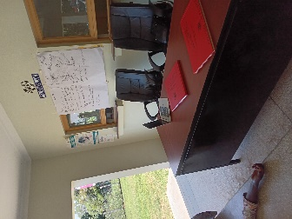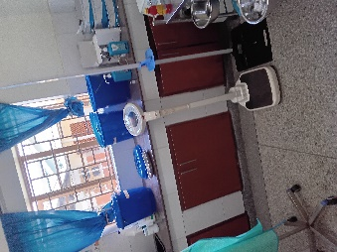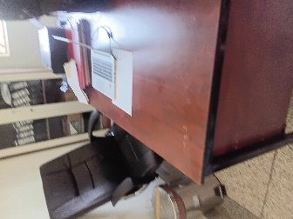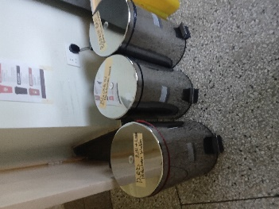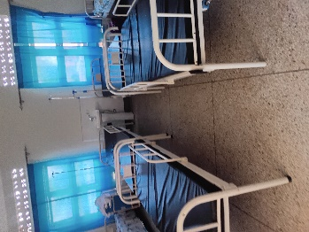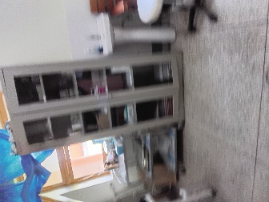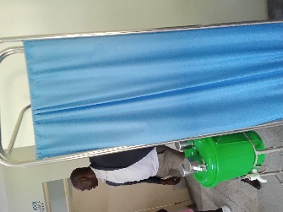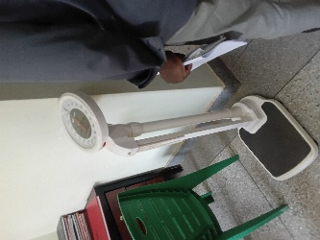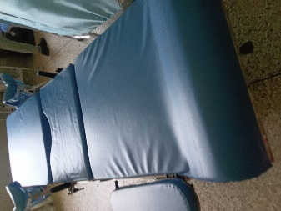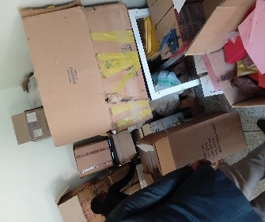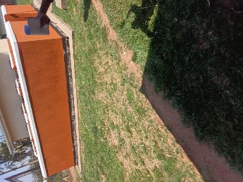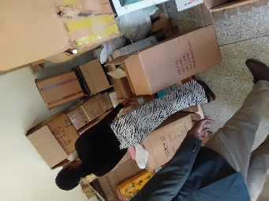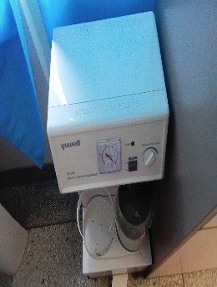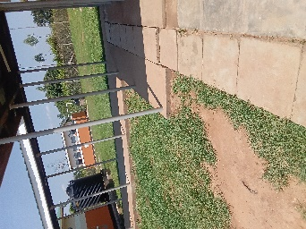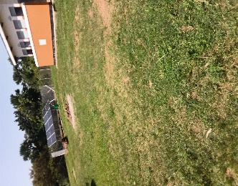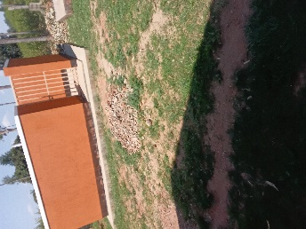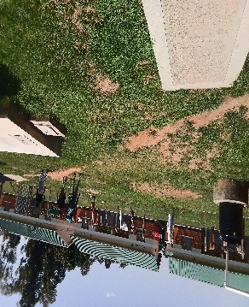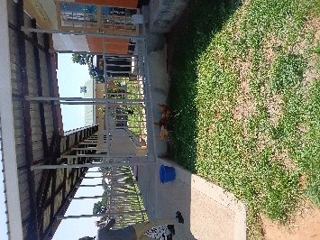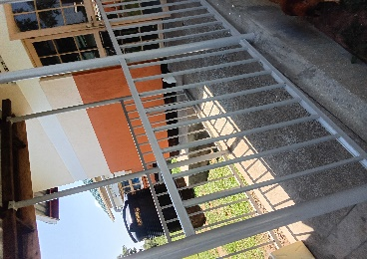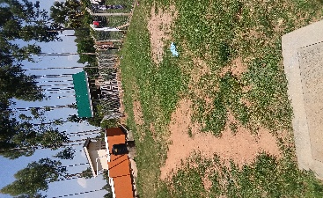

LASSANGA HEALTH CENTRE III, SOUTH DIVISION, KOBOKO MUNICIPALITY
Information from the focal person in charge of the LASSANGA HEALTH CENTRE III
- The in charge warmly welcomed the team and proceeded and went ahead to tell the team of what the facility has benefited from UGIFT Programme
- He said the Lassanga Health Centre III benefited in many things from UGIFT Programme
- This information is evidenced by the photos attached on the report.
FINDINGS
- 1 Maternity ward and general ward
- 1 Toilet and bath room with 5 units
- Water tanks
- Bed side lockers
- Office chairs
- Residential building
- 2 blocks with 4 units
- I toile and bath room then kitchen
CHALLENGES
- Limited accommodation for staff
- Lack of electricity/power
- Limited water shortages
- Limited room for patients

RECOMMENDATIONS
- Need for electricity
- Need for more staff rooms Ugift should continue
- Need for more water tanks
- Need to construct more rooms for patients

III PHOTOS
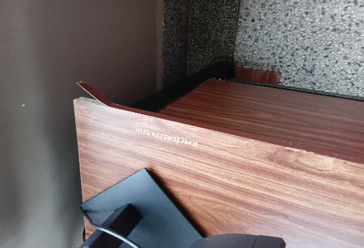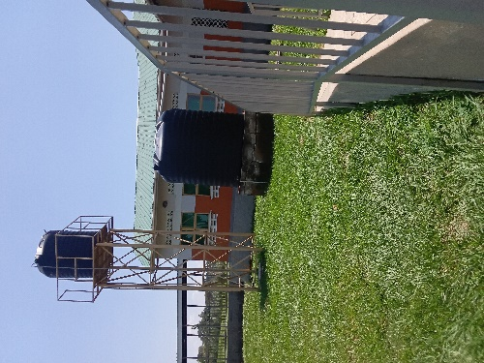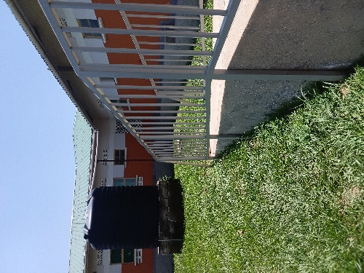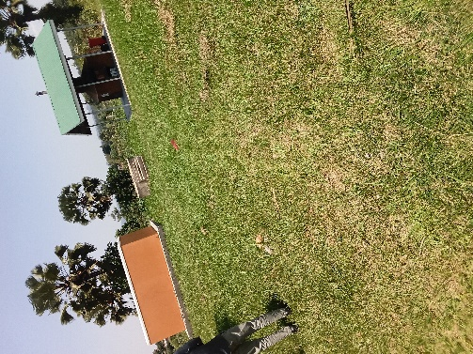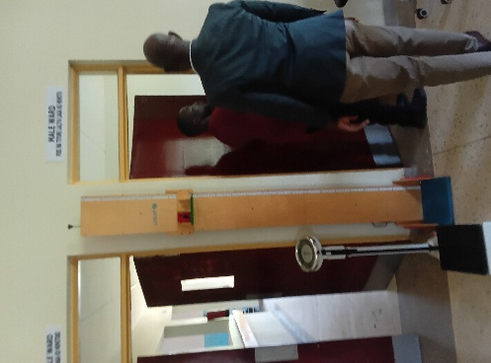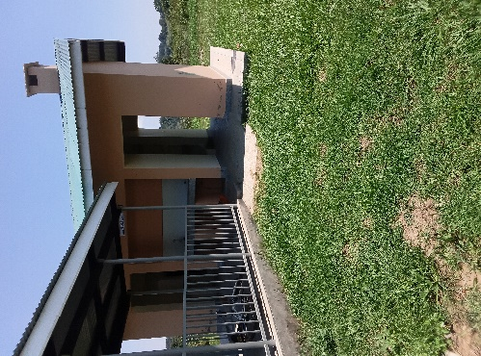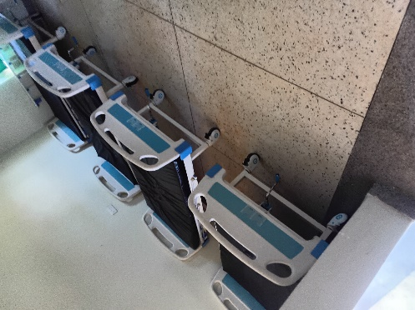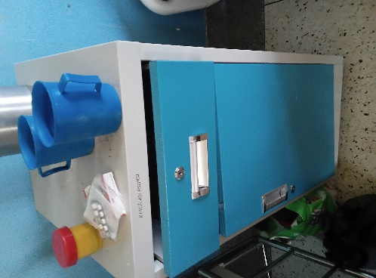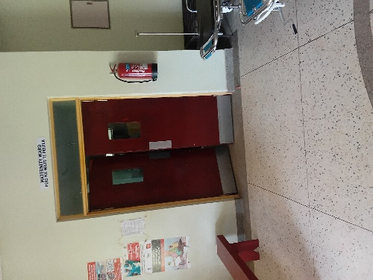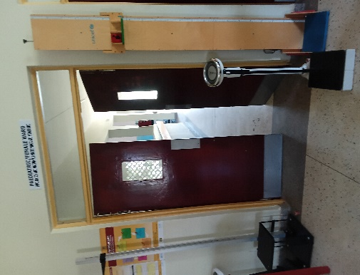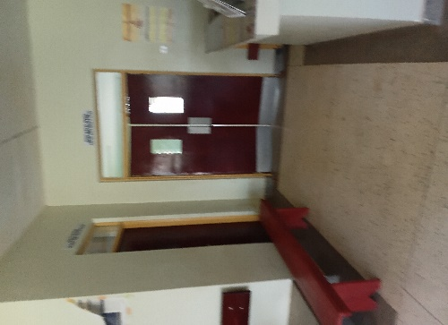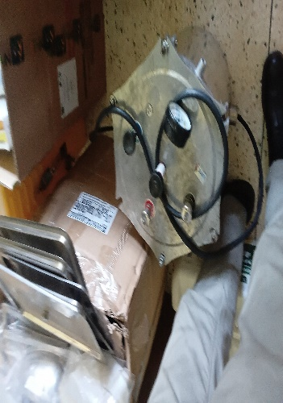

Report By: SIKIA FIKIRA
Tel: 0783517165
Email: fikirasikia@gmail.com

